DESIGN AND FUNCTIONAL SIMULATION OF LAND ROVER FIGO FSM

BY TEAM LEXCION (MRCET)
P.S.V.S.S. MADHURIMA
P. NITHIN

13/07/2023
DATE OF SUBMISSION

ABSTRACT | 3
INTRODUCTION | 4
IMPLEMENTATION | 5
TESTING | 10
RESULTS | 11
CONCLUSION | 13
REFERENCES | 14
APPENDIX | 15

The aim of this project is to design and implement a Finite State Machine(FSM) for Figo's travel plans within the ISRO campus. Figo receives a binary sequence as input, representing its travel plans, and moves between different rooms accordingly. The FSM is designed to determine Figo's current location based on the input sequence. The project begins with an analysis of the problem statement, including the locations, transitions, and inputs/outputs and each room in the ISRO campus is assigned as a unique state represented in 3-bit binary form. The FSM is designed based on this analysis, considering the specific transitions and outputs required for Figo's travel plans. The FSM design is implemented using a Verilog HDL (Hardware Descriptive Language). The binary input sequence is received by Figo and the output is the corresponding room number representing current location of Figo. By successfully designing and implementing the FSM, Figo's travel plans within the ISRO campus can be efficiently determined. The FSM provides an accurate representation of Figo's current location based on the input sequence, facilitating effective navigation and tracking within the ISRO campus.

Objective:
The objective is to design an FSM that accurately determines Figo's location by following the specified transitions and outputs. The FSM should enable Figo to navigate through the campus according to the given input sequence and generate the correct room number as its current location. The project aims to ensure efficient and accurate tracking of Figo's movements within the campus, enhancing its navigation capabilities and facilitating effective exploration.
Problem Statement:
Designing and functional simulation of FIGO FSM (Finite State Machine) which should give its current location as output. FIGO receives a binary input and should capture the transitions between states and accurately determines its current location.
System Analysis:
- Software requirements
  - Quartus Prime Lite Edition version- 18.1
  - Model Sim – Intel FPGA Starter Edition 10.5b
  - Windows OS – windows 10
- Hardware requirements
  - 8 GB RAM
Background survey:
Finite State Machines offer a structured and systematic approach to model, design and implement systems with well-defined behavior. They enhance clarity, modularity and maintainability. Hardware Descriptive Languages are used to design these FSM’s.

Approach:
- Problem Analysis: Perform a thorough analysis of the problem statement, including understanding the states, block diagram and identifying the binary sequence input representing Figo's travel plans and the desired output of determining Figo's current location.
- State Identification: Assign a unique state representation in the form of a 3-bit binary code to each room. Identify the initial state as Room0[000], where Figo starts its journey.
- Transition Definition: Define the transitions between states based on the binary sequence input. For each state, determine the next state based on whether the input is 0 or 1. the travel plans are analyzed and transitions are established accordingly.
- Output Specification: Define the output for each state, which represents Figo's current location. The output will be the binary representation of corresponding room number associated with the current state.
- FSM Design: Design the FSM structure using the identified states, transitions, and outputs. Consider the complexity and scalability of the design, ensuring it can accommodate a larger number of rooms if required.
- FSM Implementation: Develop the Verilog code for the FSM design. The FSM can be a Mealy machine or Moore machine. Translate the FSM structure, transitions, and outputs into code, allowing for the accurate interpretation of the binary sequence input and determination of Figo's current location. The developed Verilog code is analyzed by Quartus Prime Lite edition software.
- Testing and Verification: Develop a comprehensive test bench to verify the correctness and functionality of the FSM. Test the FSM with various input sequences to ensure it correctly identifies Figo's current location. Verify the output against the expected results and address any issues encountered during testing.
- Simulation: The FSM test bench is simulated by ModelSim software. Give each input value to the FSM and update the current state accordingly. Collect the corresponding outputs generated by the FSM during the simulation.
- Synthesis: Analyze & synthesize the developed Verilog HDL code and perform fitting, placing and routing and generate area and power report. Generate ‘sof’ file and implement the design on targeted FPGA.

States:
Total 8 states labelled as Rooms and each room contains two inputs. Here Rooms are denoted with 3-bit binary representation i.e. combination of 0’s and 1’s. Output is the current location.
Binary representation of rooms is:
Room0: [000]
Room1: [001]
Room2: [010]
Room3: [011]
Room4: [100]
Room5: [101]
Room6: [110]
Room7: [111]
Inputs:
The inputs are binary values: 0 and 1
By receiving these inputs, the FIGO moves to next state.
Output:
The output will be current location of FIGO. We need to design the FSM in such a way that it outputs the current location based on the inputs received.
Block diagram:
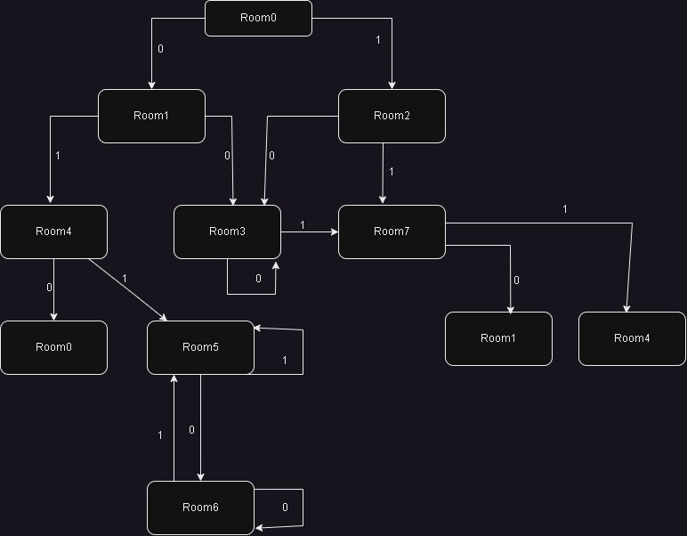
TRANSITIONS:
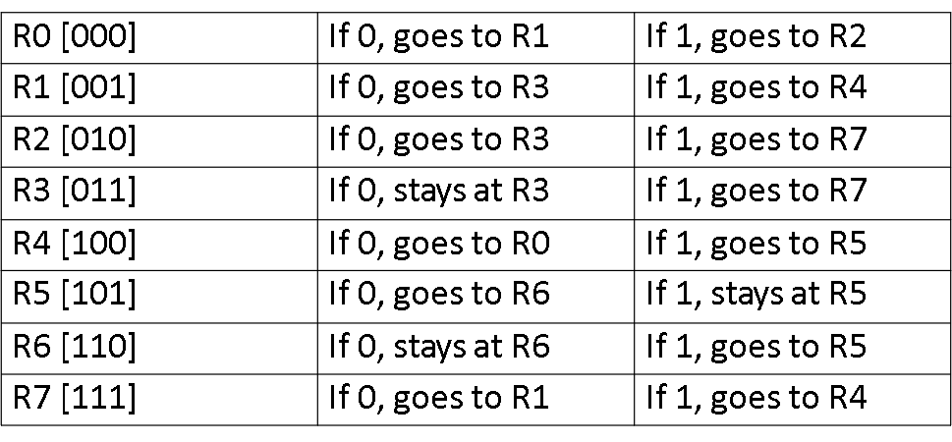
State: Room0[000]
- input ‘0’ Transition to Room1[001]
- input ‘1’ Transition to Room2[010]
State: Room1[001]
- input ‘0’ Transition to Room3[011]
- input ‘1’ Transition to Room4[100]
State: Room2[010]
- input ‘0’ Transition to Room3[011]
- input ‘1’ Transition to Room7[111]
State: Room3[011]
- input ‘0’ It stays in Room3[011]
- input ‘1’ Transition to Room7[111]
State: Room4[100]
- input ‘0’ Transition to Room0[000]
- input ‘1’ Transition to Room5[101]
State: Room5[101]
- input ‘0’ Transition to Room6[110]
- input ‘1’ It stays in Room5[101]
State: Room6[110]
- input ‘0’ It stays in Room6[110]
- input ‘1’ Transition to Room5[101]
State: Room7[111]
- input ‘0’ Transition to Room1[001]
- input ‘1’ Transition to Room4[100]

State Diagram: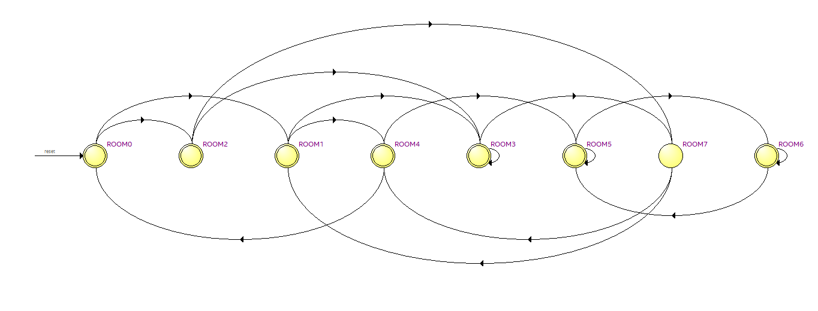
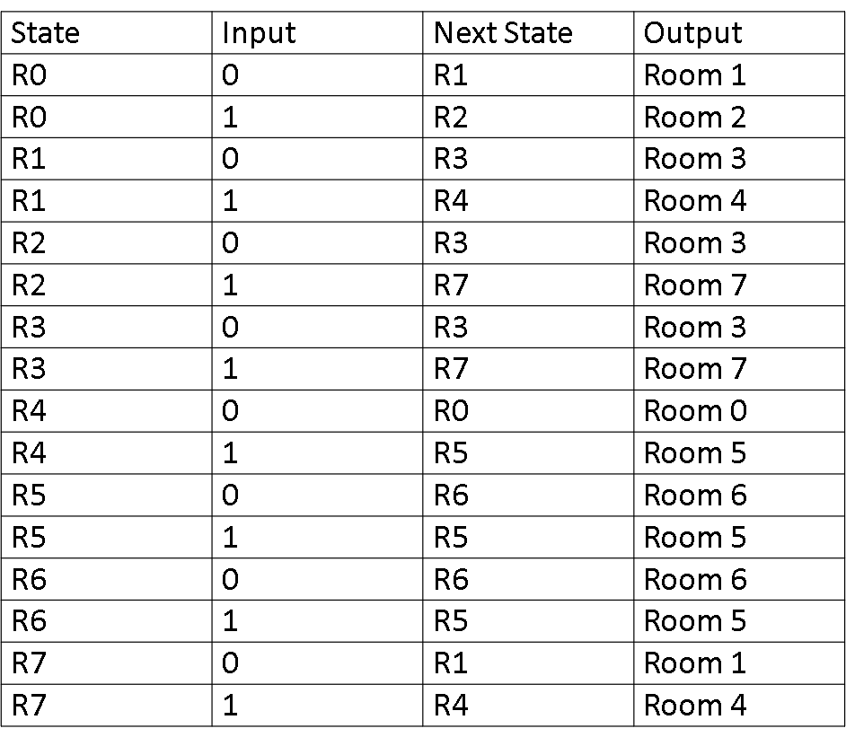
Mealy Transition table:

Mealy Machine:
A mealy machine is a type of finite state machine that is characterized by its outputs, which are determined by both the current states and the inputs. In a Mealy machine, the outputs are associated with the transitions between states. The output of a mealy machine depends on the present state of the FA as well as the current input symbol.
Used mealy machine for the design because mealy machine depends on current input and current state. The outputs of a Mealy Machine can change asynchronously in response to any change in the inputs.
Developing and synthesising:
Developed the Verilog code for design and synthesised in the Quartus Prime Lite Edition software.
After performing analysis & elaboration, test bench was created with various test plans. The test bench is simulated and the current location will be generated as an output along with wave from.
Next, performed pin planning with suitable pins and compiled the design.
Finally, performed fitting, placing &routing, assembler. The assembler process generated an sof file which is needed to be implemented on virtual FPGA board.

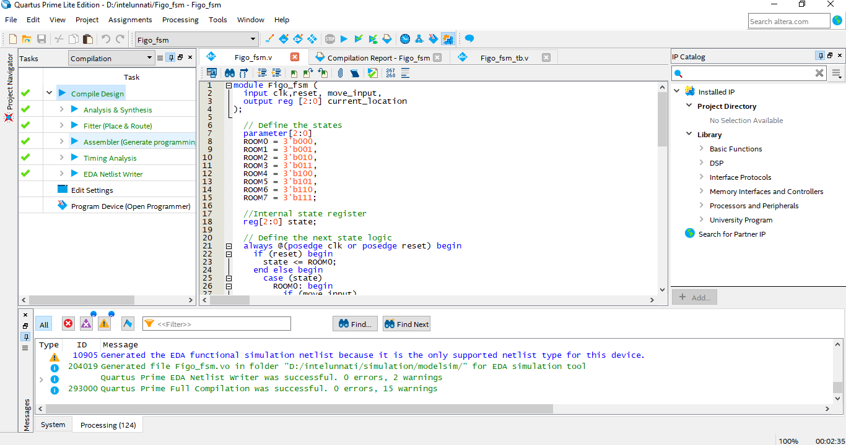

Test cases:
Input | Expected output | Actual output | Result
10001 | 111 | 111 | Success
11011 | 101 | 101 | Success
01010 | 011 | 011 | Success
01110 | 110 | 110 | Success
11001 | 111 | 111 | Success

Wave form:
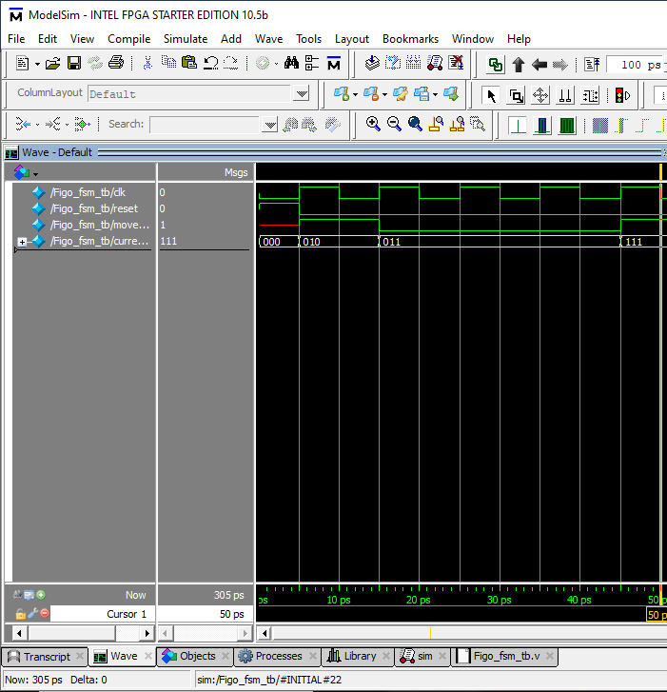

Area Report:
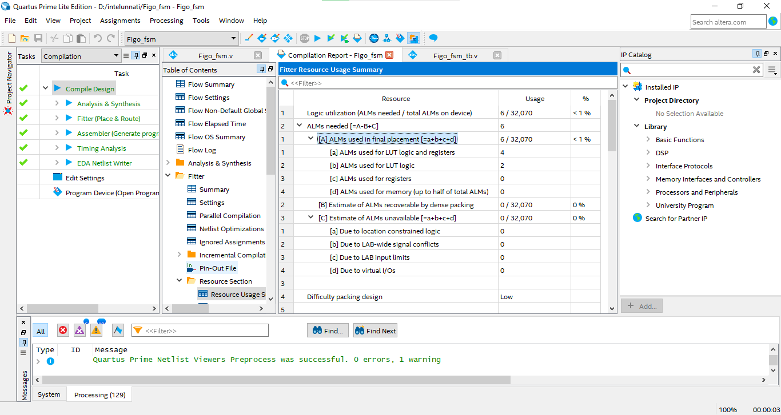

Power Report:
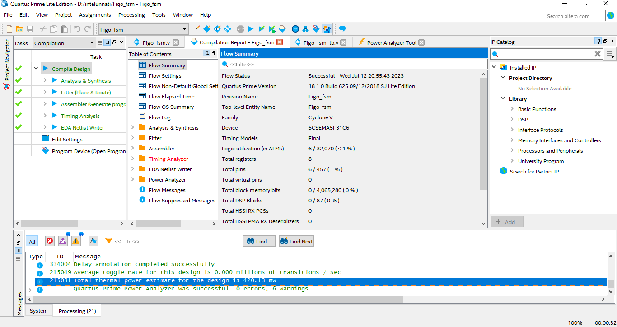

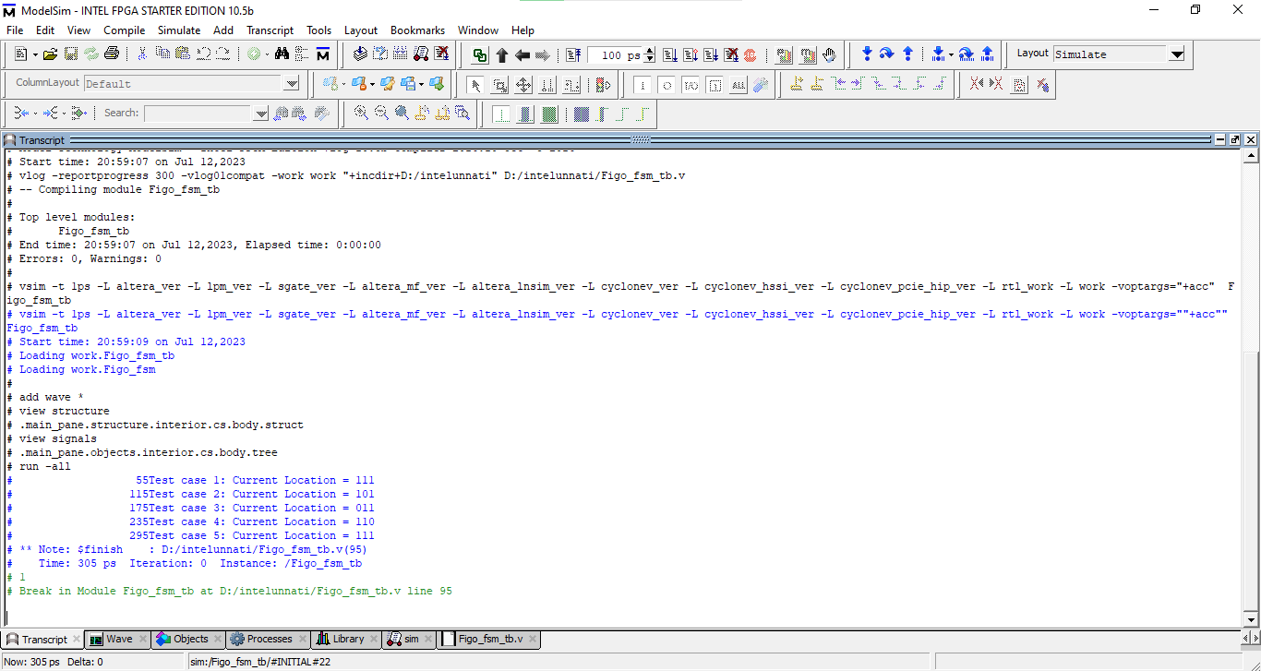
Current location displayed on transcript of ModelSim

Time Analyzer:
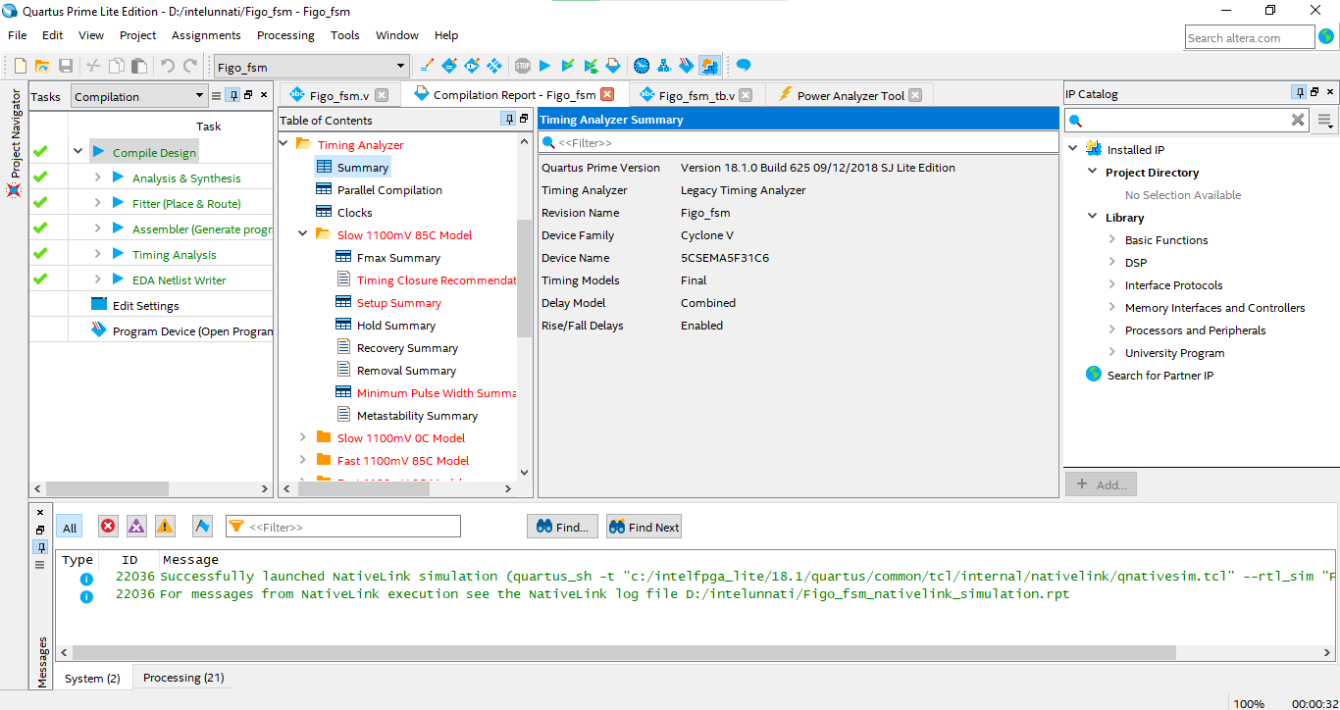

The successful implementation of the FSM for FIGO's travel plans enhances FIGO's navigation capabilities and provides accurate location information. This project demonstrates the effectiveness of FSMs in solving real-world problems and highlights their relevance in autonomous systems and robotics. The uniqueness of the project lies in its specific problem domain, incorporating robotics, navigation, and FSM design. The integration of these concepts and the real-world application contribute to the project's significance and potential impact.
Future scope:
Some potential areas of future scope for this project include computer science engineering, enhanced navigation algorithms, telecommunications, robotics, control systems. The future scope is likely to expand into various domains, enabling more efficient, intelligent and reliable systems.

- https://www.intel.com/content/www/us/en/docs/programmable/683082/22-
- https://www.intel.com/content/www/us/en/programmable/customertraining/webex/VHDL/presentation_html5.html

Verilog code:
module Figo_fsm (
input clk,reset, move_input,
output reg [2:0] current_location
);

// Define the states
parameter[2:0]
ROOM0 = 3'b000,
ROOM1 = 3'b001,
ROOM2 = 3'b010,
ROOM3 = 3'b011,
ROOM4 = 3'b100,
ROOM5 = 3'b101,
ROOM6 = 3'b110,
ROOM7 = 3'b111;

//Internal state register
reg[2:0] state;

// Define the next state logic
always @(posedge clk or posedge reset) begin
if (reset) begin
state <= ROOM0;
end else begin
case (state)
ROOM0: begin
if (move_input)
state<= ROOM2;
else
state <= ROOM1;

end
ROOM1: begin
if (move_input)
state <= ROOM4;
else
state <= ROOM3;
end
ROOM2: begin
if (move_input)
state <= ROOM7;
else
state <= ROOM3;
end
ROOM3: begin
if (move_input)
state <= ROOM7;
else
state <= ROOM3;
end
ROOM4: begin
if (move_input)
state <= ROOM5;
else
state <= ROOM0;
end
ROOM5: begin
if (move_input)
state <= ROOM5;
else
state <= ROOM6;

end
ROOM6: begin
if (move_input)
state <= ROOM5;
else
state <= ROOM6;
end
ROOM7: begin
if (move_input)
state <= ROOM4;
else
state <= ROOM1;
end
endcase
end
end
always @(state) begin
case(state)
ROOM0:current_location=ROOM0;
ROOM1:current_location=ROOM1;
ROOM2:current_location=ROOM2;
ROOM3:current_location=ROOM3;
ROOM4:current_location=ROOM4;
ROOM5:current_location=ROOM5;
ROOM6:current_location=ROOM6;
ROOM7:current_location=ROOM7;
endcase
end
endmodule
FIGO FSM testbench:
module Figo_fsm_tb;
reg clk, reset, move_input;
wire [2:0] current_location;
Figo_fsm fig (
.clk(clk),
.reset(reset),
.move_input(move_input),
.current_location(current_location)
);
// Clock generation
always begin
clk =0;
#5;
clk=1;
#5;
end
// Stimulus generation
initial begin
// Test Case 1: Figo moves five times ('1-0-0-0-1')
reset = 1;
#5 reset = 0;
move_input = 1;
#10;
move_input = 0;
#10;
move_input = 0;
#10;
move_input = 0;
#10;
move_input = 1;
#10;
$display($time , "Test case 1: Current Location = %b", current_location);
//Test case 2:Figo moves five times ('1-1-0-1-1')
reset=1;
#10 reset=0;
move_input = 1;
#10;
move_input = 1;
#10;
move_input = 0;
#10;
move_input = 1;
#10;
move_input = 1;
#10;
$display($time ,"Test case 2: Current Location = %b", current_location);
//Test case 3:Figo moves five times ('0-1-0-1-0')
reset = 1;
#10 reset = 0;
move_input = 0;
#10;
move_input = 1;
#10;
move_input = 0;
#10;
move_input = 1;
#10;
move_input = 0;
#10;
$display($time ,"Test case 3: Current Location = %b", current_location);
//Test case 4:Figo moves five times ('0-1-1-1-0')
reset = 1;
#10 reset=0;
move_input = 0;
#10;
move_input = 1;
#10;
move_input = 1;
#10;
move_input = 1;
#10;
move_input = 0;
#10;
$display($time ,"Test case 4: Current Location = %b", current_location);
//Test case5:Figo moves five times ('1-1-0-0-1')
reset = 1;
#10 reset = 0;
move_input = 1;
#10;
move_input = 1;
#10;
move_input = 0;
#10;
move_input = 0;
#10;
move_input = 1;
#10;
reset=1;
$display($time ,"Test case 5: Current Location = %b", current_location);
#10 $finish;
end
endmodule

